Some examples of KeyHold time courses. Nov 27, 2011

For Subjects 01, 03, 06 (AECOM)
07 that had some very long KHs
08.

JR uses program
Nplots_KHvst.m
or
plotKHvst.m

But did not include the final KHs, just for convenience to avoid treating special cases of just a DOWN or carry over into next run. Note, in some cases we see very brief initial KH in a run. This is from a carryover from previous run: a KH occurred after sound finished but maybe even after the ‘clear KeyPresses’ was issued. In updated (Nov 23 2011) StTripNtrials the ‘clear KeyPresses’ was moved to just prior to play(AP) so there should be no carryovers.

Looking at data we see very little overlap in leftarrow or rightarrow KeyPresses.
Red is for 2-streams percept, Blue is for 1-stream percept.

We can maybe see the trend that the number of longer red bars increases as DF increases.

Subj 01, 3 DFs 1 trial. NOTE: Subj 01 is a fast switcher.
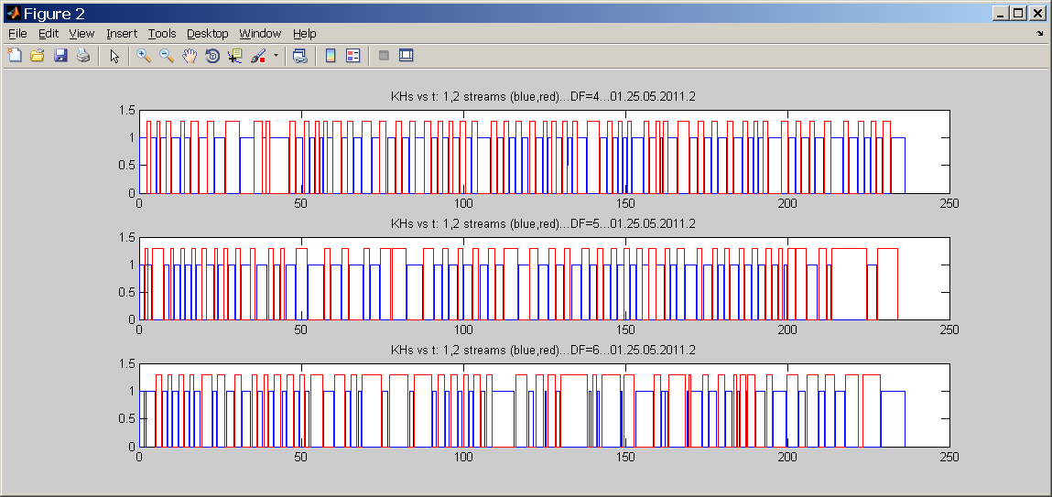

Subject 03. DF=4,5,6 2 trials

